**//Carraige.js //To add forward force to Carriage**

#pragma strict

private var speed:float;

function Start () {

speed=1.0f;

}

function Update () {

transform.Translate(speed,0,0);

}

**//Timer1.js //To enable/disable Timer and display “GameOver”/”YouWin” Text**

#pragma strict

public TimeText: GUIText;

public ScoreText:GUIText;

public TotalText:GUIText;

public Totalt:GUIText;

public var alertReference : GameObject;

public var youWT : GameObject;

private var rdl : redolevel;

function Start () {

Screen.sleepTimeout = SleepTimeout.NeverSleep;

Screen.orientation=ScreenOrientation.LandscapeLeft;

Camera.main.GetComponent(AudioSource).Play();

TotalText.enable=false;

Totalt.enable=false;

rdl=Camera.main.GetComponent(redolevel);

rdl.enabled=false;

Time.timeScale=1;

InvokeRepeating("ReduceTimer",1,1);

}

function Update () {

}

function ReduceTimer() {

if(TimeText.text=="1")

{

Time.timeScale=0;

if(int.Parse(ScoreText.text)>=20)

{

Instantiate(youWT,new Vector3(0.5f,0.5f,0),transform.rotation);

TotalText.text=(int.Parse(ScoreText.text)*10).ToString();

TotalText.enabled=true;

Camera.main.GetComponent(AudioSource).Stop();

}

else{

Instantiate(alertReference,new Vector3(0.5f,0.5f,0),transform.rotation);

rdl.enabled=true;

Camera.main.GetComponent(AudioSource).Stop();

}

}

TimeText.text=(int.Parse(TimeText.text)-1).ToString();

}

**//Opponent.js**

#pragma strict

private var speed:float;

public ScoreText:GUIText;

function Start () {

speed=1.0f;

}

function Update () {

speed=Random.Range(1.0f,5.0f);

transform.Translate(speed,0,0);

if(Input.touchCount = 1)

{

Instantiate(arrow,new Vector3(GameObject.x,GameObject.y,GameObject.z),Quaternion.Identity);

}

}

function OnTriggerEnter(other : Collider)

{

if (other.tag == "Arrow" && gameObject.tag=="Opponent")

{

ScoreText.text+=10;

return;

}

}

**//Start Screen**

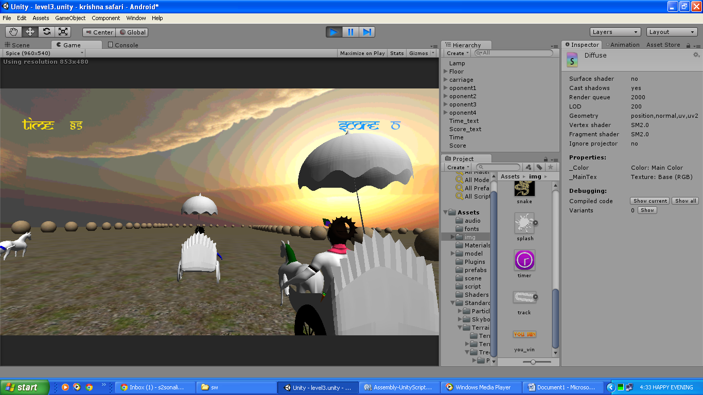

**//Game Over Screen**

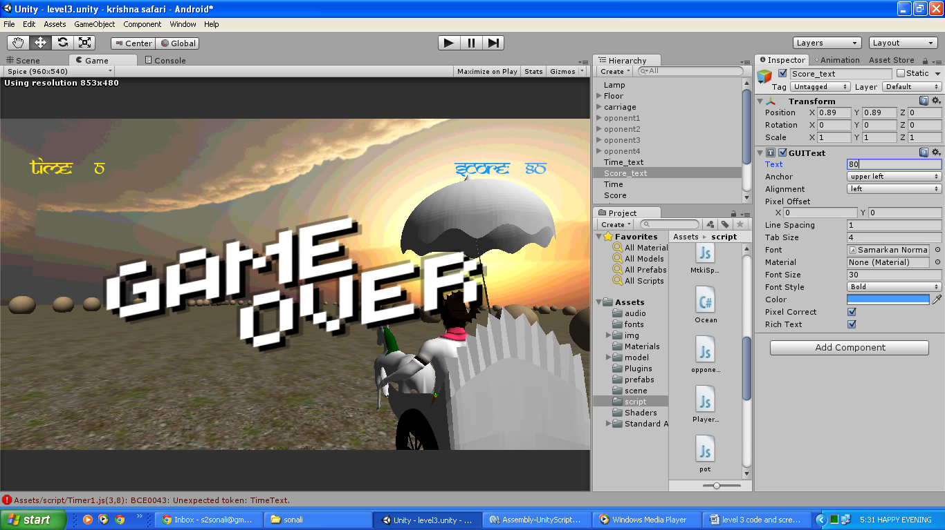

**//You Win Screen**

